Internship Report - Day 3
Name : Rickshtiha A
Intern ID : CDM/INT/202607608
Topic: NumPy Fundamentals

Objective
The objective of Day 3 was to learn the fundamentals of the NumPy library in Python. The session focused on creating NumPy arrays, performing indexing and slicing operations, executing mathematical calculations, and understanding how NumPy improves numerical computation compared to regular Python lists.

Tasks Completed
- Installed and imported the NumPy library.
- Learned about one-dimensional and two-dimensional arrays.
- Practiced array creation using different NumPy functions.
- Performed array indexing and slicing.
- Learned mathematical and statistical operations on arrays.
- Executed array-based calculations.
- Compared NumPy arrays with Python lists.

Introduction to NumPy
NumPy (Numerical Python) is a powerful Python library used for scientific computing and numerical operations. It provides a fast and efficient multidimensional array object along with mathematical functions for performing operations on arrays.
Advantages of NumPy
- Faster than Python lists
- Supports multidimensional arrays
- Easy mathematical computations
- Efficient memory usage
- Widely used in Machine Learning and Data Science

Topics Learned
1. Importing NumPy
import numpy as np

2. Creating Arrays
One-Dimensional Array
import numpy as np

arr = np.array([10, 20, 30, 40, 50])
print(arr)
Output
[10 20 30 40 50]

Two-Dimensional Array
matrix = np.array([[1,2,3],
[4,5,6]])

print(matrix)
Output
[[1 2 3]
[4 5 6]]

3. Array Indexing
arr = np.array([10,20,30,40,50])

print(arr[0])
print(arr[3])
Output
10
40

4. Array Slicing
arr = np.array([10,20,30,40,50])

print(arr[1:4])
Output
[20 30 40]

5. Mathematical Operations
a = np.array([1,2,3])

b = np.array([4,5,6])

print(a + b)
print(a - b)
print(a * b)
print(a / b)
Output
[5 7 9]
[-3 -3 -3]
[ 4 10 18]
[0.25 0.4 0.5 ]

6. Statistical Functions
arr = np.array([10,20,30,40,50])

print(np.sum(arr))
print(np.mean(arr))
print(np.max(arr))
print(np.min(arr))
Output
150
30.0
50
10

7. Array-Based Calculations
marks = np.array([78,82,91,65,88])

average = np.mean(marks)

print("Average Marks =", average)
Output
Average Marks = 80.8

Programs Practiced
Program 1 – Square of Numbers
import numpy as np

numbers = np.array([1,2,3,4,5])

print(numbers ** 2)
Output
[ 1 4 9 16 25]

Program 2 – Find Maximum Element
import numpy as np

arr = np.array([25,15,48,75,10])

print("Maximum =", np.max(arr))
Output
Maximum = 75

Program 3 – Addition of Two Arrays
import numpy as np

a = np.array([1,2,3])

b = np.array([4,5,6])

print(a+b)
Output
[5 7 9]

Applications of NumPy
- Machine Learning
- Artificial Intelligence
- Data Science
- Image Processing
- Scientific Computing
- Data Analysis
- Deep Learning

Expected Outcome
- Learned the basics of the NumPy library.
- Created one-dimensional and two-dimensional arrays.
- Performed indexing and slicing operations.
- Applied mathematical and statistical functions on arrays.
- Successfully completed array-based programming exercises.
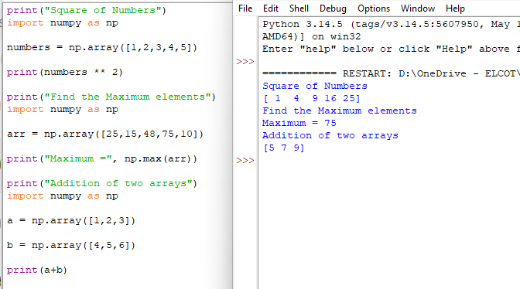
Learning Outcome
On Day 3, I developed a strong understanding of NumPy fundamentals. I learned how to create and manipulate arrays, perform mathematical and statistical operations efficiently, and use NumPy for numerical computing. These skills provide a solid foundation for future work in data analysis, machine learning, and artificial intelligence.

